NALA 85480 Info Flash N°4
May 2012

Nos Amis Les Animaux 85480 is an association Loi 1901 (W852002671) which was established in September 2010 to educate and inform the local public about the plight of animals and to help lost or abandoned animals.

--------------------------------------------------------------------------------
Thank you for your financial support! Here're some examples of what we spent it on...

Carrera's story

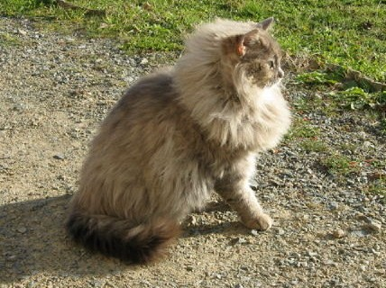

Carrera, a wonderful Persian cross cat, was found and taken in by a family that cares a lot about animals, but which didn't have the resources to keep her and to pay for extra vet bills, as Carrera had a skin problem that gave her a lot of pain and discomfort. In addition they already had a cat, so they phoned NALA85480 to ask whether we could help her. A couple of vet appointments and tests later it was clear why Carrera was suffering. She had a fungus infection that had spead to her nose, her eyes, her mouth and even her tummy. With the right medication, which the family patiently gave her for a couple of weeks (and we thank them for it!), Carrera became this beautiful little lioness, who not long afterwards was adopted by a good family in Chantonnay.

Gamey's story

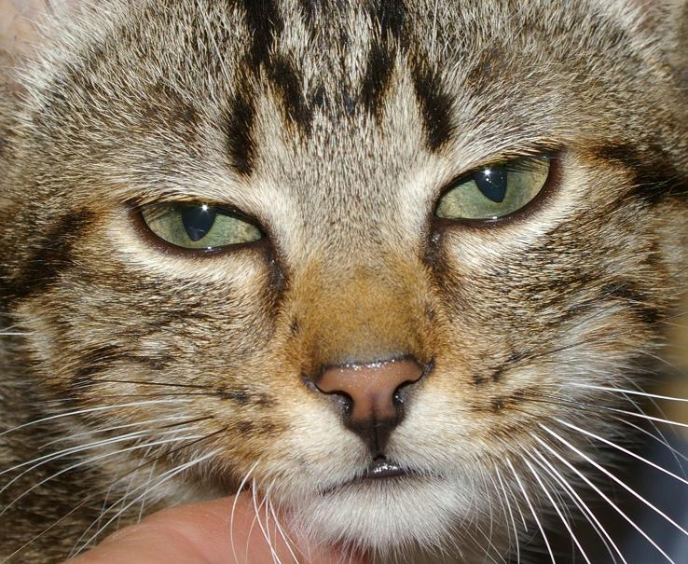

Meet Gamey, the little kitten, who not even 4 months old, was found in the ditch by a main road, and who needed major surgury on his broken leg. His operation cost us an arm and a leg but he is definitely worth it. This lively little boy has totally recovered and is enjoying his new family, the outdoors and the many other cats he can play with.

For these animals it ended well. However there are so many other animals in the Vendée in need of extra care and attention.

Huia's story

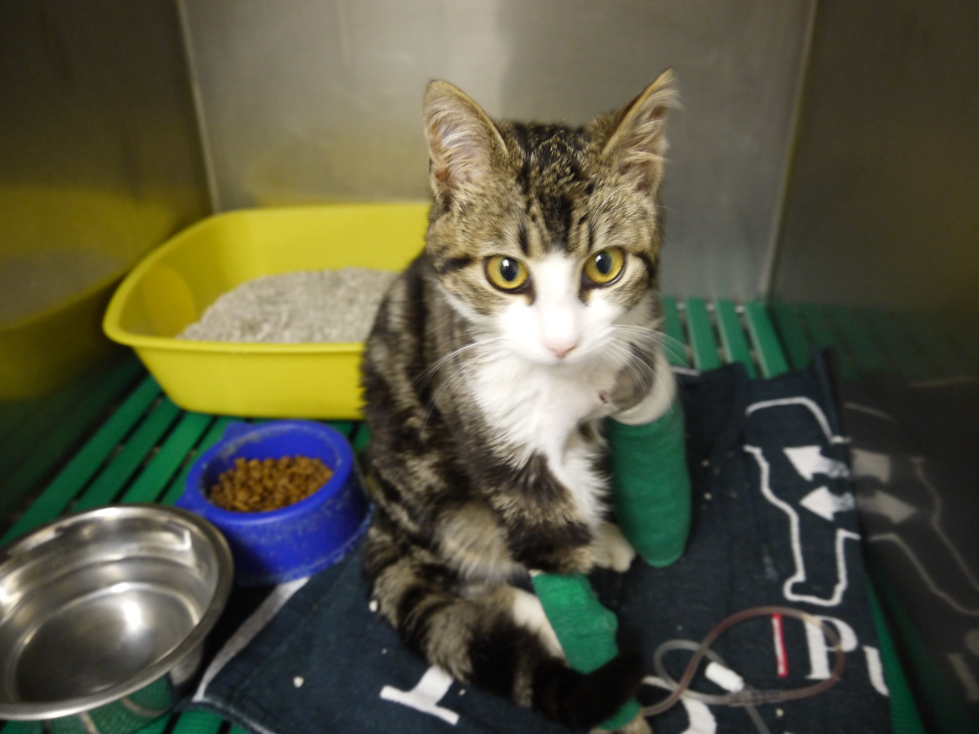
Just recently.... a local vet asked us to help save a cat with a double fracture of the radius/ulna due to a gunshot wound. (Sometimes we almost dispair that people shoot at (young) cats.) The owners wanted to have him put down because they could not afford the surgery. Along with the vet we felt that it would be a shame to put down this young and lively cat, called Huia, so we agreed to cover part of the cost of the operation which is €461. The owners have agreed to pay €75 which would have been the cost of putting him down and cremation, but don't want to keep him. To cover the short fall, we posted this story on our web site and asked for donations. Thanks to some very generous people we have raised over half the money needed.
Huia had a successful operation on Wednesday 18th April and is recovering well at the vets. In a couple of weeks he will go to a foster family who are prepared to adopt him if all goes well between him and their other animals.

If you would like to make a donation towards Huia's hospital bill, please send it to NALA 85480, 2, Place de la Mairie, 85480Bournezeau.

--------------------------------------------------------------------------------
Foster Families

Since the creation of NALA 85480 in Spetember 2010 we have rehomed more than 100 animals, thanks to the foster families who could take care of them until we found the right family. We are really grateful for their help. The number of animals increases though and this summer we are expecting, once again, to have many kittens that need saving. We desperately need more foster families to look after animals until we can find a new owner for them. If you're interested please contact Marit or Nathalie on 06 48 68 40 37
We pay for their food, vet bills, transport etc so it doesn't cost you anything.

http://www.nosamislesanimaux.com/devenir-famille-daccueil-de-nala.php

--------------------------------------------------------------------------------
NALA meeting with the Chief of Staff of the President of the Conseil Général
As a result of the letter signed by nearly every animal protection organisation in the Vendée, that we sent to the President of the General Council, we were invited to meet with his Chief of Staff on 4th April 2012.
The atmosphere of the interview was very pleasant and informative. We gave an overview of the current situation in the Vendee for stray animals especially cats and kittens: the fact that many are not identifiedn, the problems of non-sterilization, the almost total inaction of town halls for cats, and the lack of compliance with the law by owners (identification,abandonment, abuse etc.). The Chef de Cabinet was very surprised that at the extent and seriousness of the current situation.
He was in favour of publishing something along the lines of the article that was written by a member of NALA 85480 "Changing Law, Changing Mindset" in the
Journal de laVendée and if possible would get a journalist to contact us.
Regarding the responsibility of Mayors towards stray animals, he suggested that we contact the Director of the Association of Mayors (the Chief of Staff offered to call him in advance) for a discussion on possible actions to raise awareness on this subject.
He explained that the role of the Conseil Général is limited to a number of specific areas, which do not include animals. To tackle the issue of people not complying with the legislation he suggested that we talk to the Préfet.
So overall, this meeting did not lead to any concrete progress being made, but it's a step in the right direction, especially if we do get something published in the Journal de la Vendée.
We've recently contacted the préfecture and the Association of Mayors, asking for meetings.
To be continued ...

--------------------------------------------------------------------------------
Program NALA for 2012

Sunday 15th April
* Vide grenier in Cheffois
inside the salle

Sunday 6th May
* Bring and Buy Plant sale, bric a brac, craft gifts, books, tea and delicious home made cakes, cream teas (with real clotted cream!)
La Sauvagère on the road between Mouilleron en Pareds and St Maurice le Girard
from 2 PM until 6 PM

Sunday 10th June
* Vide Grenier in Bazoges en Pareds
Saturday 16th of June
* Concert/dance with the French Connection covering songs of the 60's/90's and Nigel who covers Elvis, Sinatra and Bublé
in the “Salle du Chêne Vert” 47 rue Nationale, 85390 Mouilleron en Pareds.
The concert starts at 8 PM (doors open at 7.30 PM).
Entrance fee 10 euros. Reservation either by phone (06 52 6008 84) or nala85480@hotmail.com

Sunday July 1st
* Vide Grenier in Vouvant

Sunday July 15th
* Vide Grenier in Bournezeau

Saturday 11th August
* Vide Grenier in Moutiers les Mauxfaits

Sunday 30th September
* Vide Grenier in Mouilleron en Pareds

If you would like to help with these events or organise you own event please get in touch with us on 06.48.68.40.37 or send us a mail to nala85480@hotmail.com. The more the merrier and it is for a good cause.

--------------------------------------------------------------------------------
SURVEY 85480 NALA
Nala 85480 Association has began an investigation into poisoned, injured, killed, missing dogs and cats in the Vendée to find out what's happening behind the scenes.
We will send the results to the relevant authorities. If you too have something to report, please complete the form on our website http://www.nosamislesanimaux.com/enquete-nala-85480.php. Your contact information (which is not compulsory) will be treated confidentially. Thank you!

--------------------------------------------------------------------------------
Information day Mouilleron en Pareds in January

We received a lot of positive feedback from our information day. Amongst the visitors and participants were Mr Valentin Josse, conseiller général du Pays de la Chataigneraie, local councillors from Mouilleron en Pareds, the Police Municipale of Chantonnay, a vet and the Dog Club from Chantonnay, and associations such as NALA 85480, GALIA, the SPA from la Roche sur Yon and L'Ecole du Chat Libre Caillerot. So there will certainly be a follow-up day in the future to inform people as well as the town councils about the obligations but also the pleasures of pets. More details about the day can be found at: http://www.nosamislesanimaux.com/conf%C3%A9rence-vivre-avec-nos-animaux.php

--------------------------------------------------------------------------------

Dealing with animal neglect

The recent cold conditions have highlighted cases of animals being kept in sub-optimal (that's a polite way of saying “appalling”) conditions. It's mainly dogs that seem to suffer with owners attaching them to chains all day long and not providing adequate shelter or access to (unfrozen) water. Unfortunately French law allows dogs to be chained up providing the following conditions are met: the dogs should be attached with an appropriate collar to a chain of min 2.50 meters/3 meters, food and water should be available, their kennel should be above the ground, of good quality, clean, insulated, oriented to the south, supplied with bedding in winter, etc. The suitability of living conditions for animals is covered by Arrêté du 25 octobre 1982 relatif à l'élevage, à la garde et à la détention des animaux, chapter II.

So what should you do if you spot an animal that you think is suffering from neglect/mistreatment? One thing that we have to make clear is contrary to what we are generally used to in our home countries, the small animal protection organisations in France such as Nala 85480 have no authority to intervene. Nevertheless, by using a mixture of bluff and persistance we sometimes can get the appropriate authorities to act.

The official body that should deal with cases of animal neglect/mistreatment is the Direction Départementale de la Protection des Populations, formally known as the Direction Départementale des ServicesVétérinaires (Departmental Veterinary Service). Perhaps I'm reading too much into the change of name, but in the Vendéee it appears that animal welfare is not their first priority. Contact them: not only by phone/e-mail but also by letter. Send a copy of your complaint to the Mairie of the town where you have seen the animal. Just to keep them on their toes inform a national animal protection organisation like the Brigitte Bardot Foundation and/or the SPA and let all of them know that you have contacted the others.

For cases of flagrant abuse and where there is immediate danger you can also contact the Gendarmerie or Police Municipale if the town has one.

If it is possible without putting yourself at risk, try to get some photos or even a video of the situation. That way it's easier to see if any changes have been made.

If you need help with writing an appropriate letter in French, please contact us on 06 48 68 40 37 (English speaking) or nala85480@hotmail.com

--------------------------------------------------------------------------------

Members corner

What an adventure for Poussière, my 8 year old cat... Lauri reveals all...
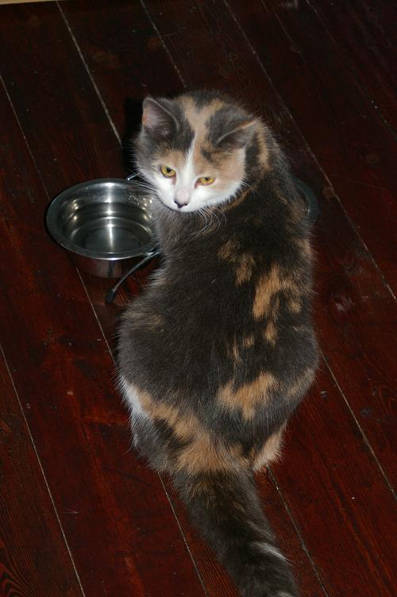
One evening in January (10.1.2012), Poussière escapes from my house. I call her and look for her but don't find her. Days pass and there is still no sign of her. A month goes by and I'm so sad to have lost her that I decide to sell all her stuff (scratching post, bowl, litter box.) On the “Le bon coin” website. To get an idea of the prices of other sellers, I look at the animal ads. And there! What do I come across??.. An ad with a picture of Poussière!!! I am so happy that I don't notice the time (10:15 p.m.) and call the number shown. I'm in contact with the association NALA85480.
Poussière was found on 12th January in Chantonnay. FYI I live in Chauché, I work in St Germain de Princay and went to Chantonnay once in January, the day after Poussière disappeared . How she made the trip from my home to Chantonnay will always be a mystery. Was she is taken by someone who dumped her there or did she get into my car? I'll never know. Since she is not at all wild, someone found her and reported her to the Police Municipale, Chantonnay as lost. Poussière spent two weeks in their kennels, which could have been avoided if I had had her identified.
The reunion took place on 13th February and Poussière is now identified. Poussière and I were so happy. The return home went very well. She quickly resumed her old habits and took up with her old mate, Funky (my Jack Russell).
I want to say a big THANK YOU to the association NALA85480, because thanks to them, I got back my missing cat. Now we have many fun moments together, full of games and cuddles. Funky, my friends and family and I are very happy to have her back !
But the main lesson of this story is that I should have identified my cat.
Laurie

--------------------------------------------------------------------------------
Other associations
Vivre et laissez Vivre (Live and let live) Associations, for the rescue, defence and care of pets and other animals at St Jean de Monts.
http://www.vivre-et-laisser-vivre.com/
The President of the Association, Mrs Gabriella Baran:
"I love animals, all animals: whether or not they are beautiful or friendly, whether they live in water, in the air, on the land or underground, even whether they have or don't have eyes... but I have a fondness for cats. It seems inconceivable to me to eat animals, but this is only my opinion. I am a vegetarian and very happy not to contribute to the suffering of billions of animals.
I adopted 16 cats, four dogs, a goat and I was contacted daily about others. Unfortunately, my budget was and still is really tight and totally inelastic. So I decided with my partner (also vegetarian) to create a small association "Live and Let Live!" registered 25th September 25, 2005 so that those who wish can help us feed and care for our proteges by making a payment to payment, large or small to Credit Agricole, Account No. 000 535 041 25 or cheque made out to association "Vivre et Laisser Vivre", la petite vigne, route de beauvoir, 85160 ST JEAN DE MONTS or via our site: http://www.vivre-et-laisser-vivre.com/categorie-0.html by clicking on donate via Paypal!
25th April, 2012 Today our goat is in goat heaven. Our four dogs are still there. But now we have 42 cats, some are too old to be adopted but still enjoy a happy life and give us lots of cuddles!
On 19th and 20th May 2012 we are organising days of information and awareness on the plight of stray and abandoned cats! If you're in the area, feel free to pop in. "

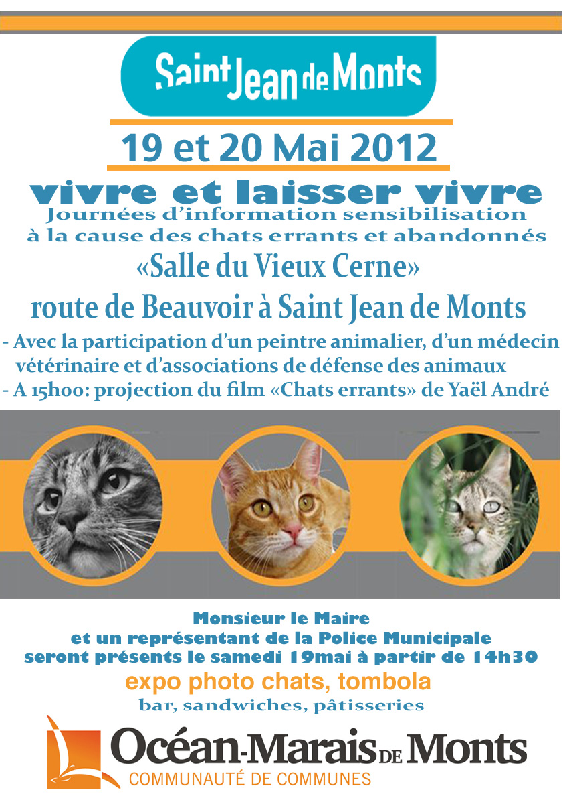

--------------------------------------------------------------------------------

Last but not least: Animals waiting to be adopted

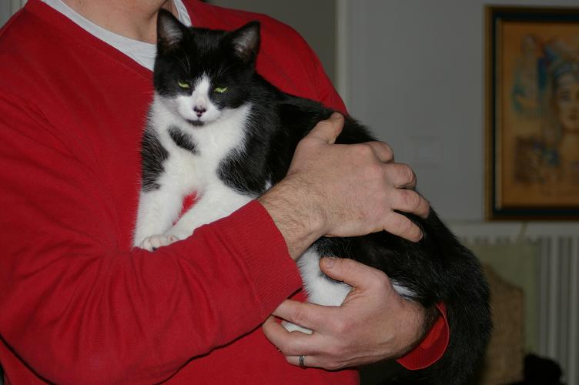
Gizmo is a little kitten (male) adorable and sweet, 6 months old, a real cutie. He is microchipped, vaccinated and tested. He is in a foster home with other cats and a dog (Beagle) in Fougeré.
Hitsuko: a male cat about a year old, microchipped, vaccinated, treated against fleas / worms and neutered.
Hitsuko,is a real pet cat, that follows you everywhere.
Hitsuko is also a cat who likes to go out, a confirmed mouser. He is territorial, so we are looking for their family with a house and garden, with no other pets and children. Hitsuko knows what he wants. He loves to play, but lets you know when he's had enough.
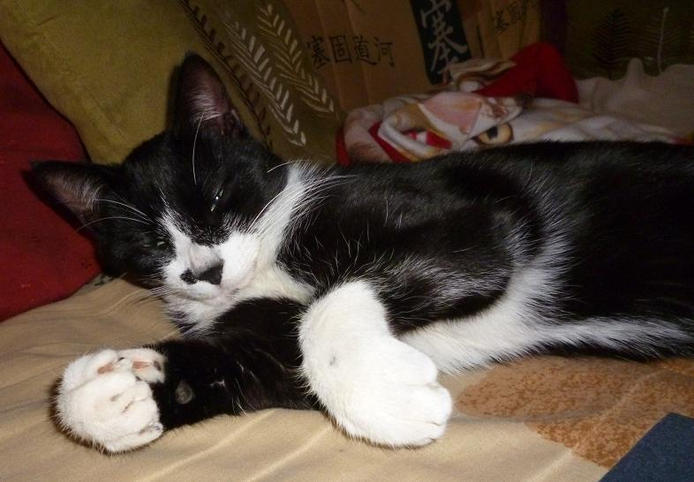

This beautiful male cat Bagheera is very cuddly and affectionate. He likes to stroll in the fields and bring back a rabbit, he also takes care of mice! That's part of being a cat.
He's OK with poultry and gets on well with a calm and gentle dog where he is now staying
He is neutered and vaccinated and will be identified before adoption.

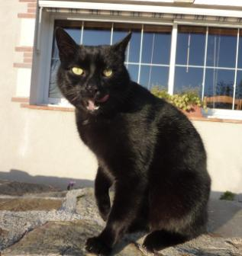

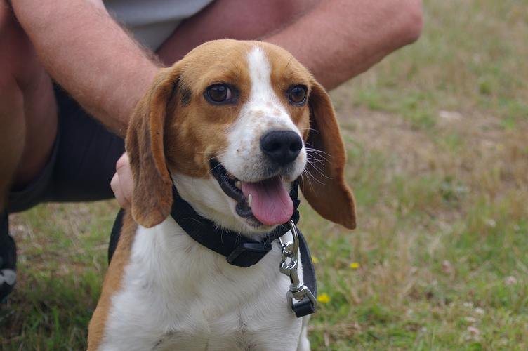
Emir, a three year old Beagle who lives in the countryside. He is very enthousiastic and energetic. He gets along well with dogs, cats, sheep, goats and children.He is not well educated but he has a very nice temperament.
And of course all the other animals (rats, guinea pigs, kittens and cats) waiting to be adopted. You can find them on NALA's site: http://www.nosamislesanimaux.com/les-animaux.php
For information please call us on 06 52 60 08 84 or email nala85480@hotmail.com
--------------------------------------------------------------------------------
Please join us and become a member!
Together we can do more to help animals.
We need volunteers who can organise:
... raffles, coffee mornings, afternoon teas
... stalls for vide greniers throughout the Vendee
... awareness campaigns about the adoption, neutering for dogs and cats, the identification of dogs and cats
... other events such as concerts, shows, dinner dances etc..
And we seek:
...a volunteer lawyer to help us in matters of law
In short: your ideas, help and donations are welcome!
Feel free to call us for information 02 28 15 09 76/06 48 68 40 37 or send an email tonala85480@hotmail.com

--------------------------------------------------------------------------------

© NALA 85480, Mai 2012, Bournezeau

Tél. 02 28 15 09 76 / 06 48 68 40 37 (06 52 60 08 84 pour les adoptions)

Mail nala85480@hotmail.com

Contributions : Nathalie Ducep, Marit de Haan

Nala Bournezeau sur facebook: http://www.facebook.com/profile.php?id=100002135097263

Le forum: http://nala85480.xooit.fr/index.php

Le site: www.nosamislesanimaux.com

